**Task Description**

The task includes -

* Creating AWS VPC and also creating 2 public subnets and two private subnets in it
* Creating route tables, internet gateway, NAT gateway
* Creating security groups and NACL and launching AWS EC2 instances through CLI

About **AWS VPC** -

1. Amazon Virtual Private Cloud (Amazon VPC) allows users to launch Amazon Web Services (AWS) resources into a virtual network that is **isolated from the public Internet**.
2. With VPC, users have **complete control over their virtual networking environment**, including the selection of IP address range, creation of subnets, and configuration of route tables and network gateways.
3. VPC **provides advanced security features**, such as security groups and network access control lists, to enable inbound and outbound filtering at the instance and subnet level.
4. Additionally, VPC enables users to connect their existing IT infrastructure to the cloud using industry-standard encrypted IPsec VPN connections.
5. Overall, **VPC is a flexible and scalable solution for deploying and managing AWS resources in a virtual network.**

**Screenshots of the tasks :**

* Created AWS VPC and also created 2 public subnets and 2 private subnets in that VPC

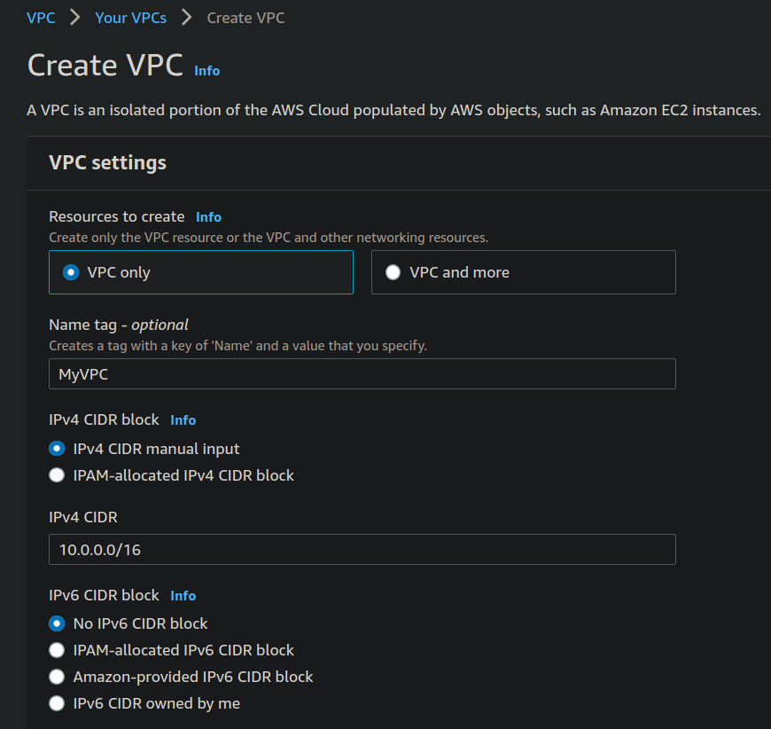

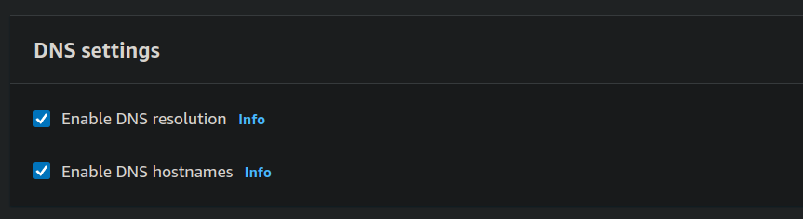

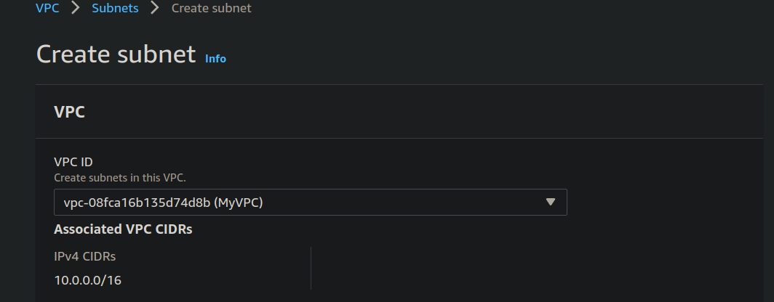

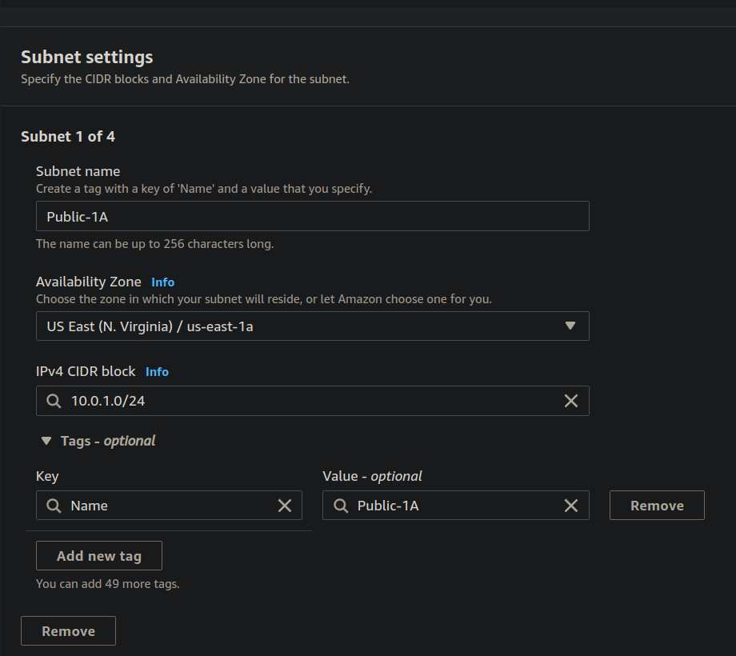

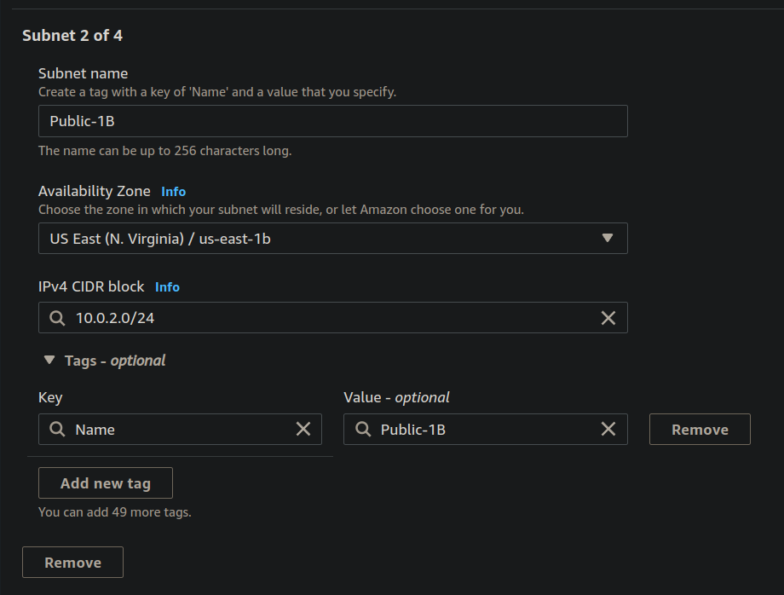

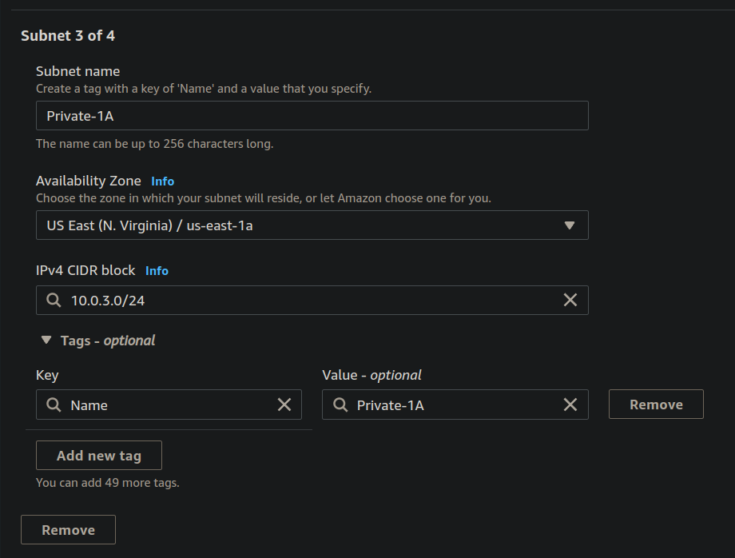

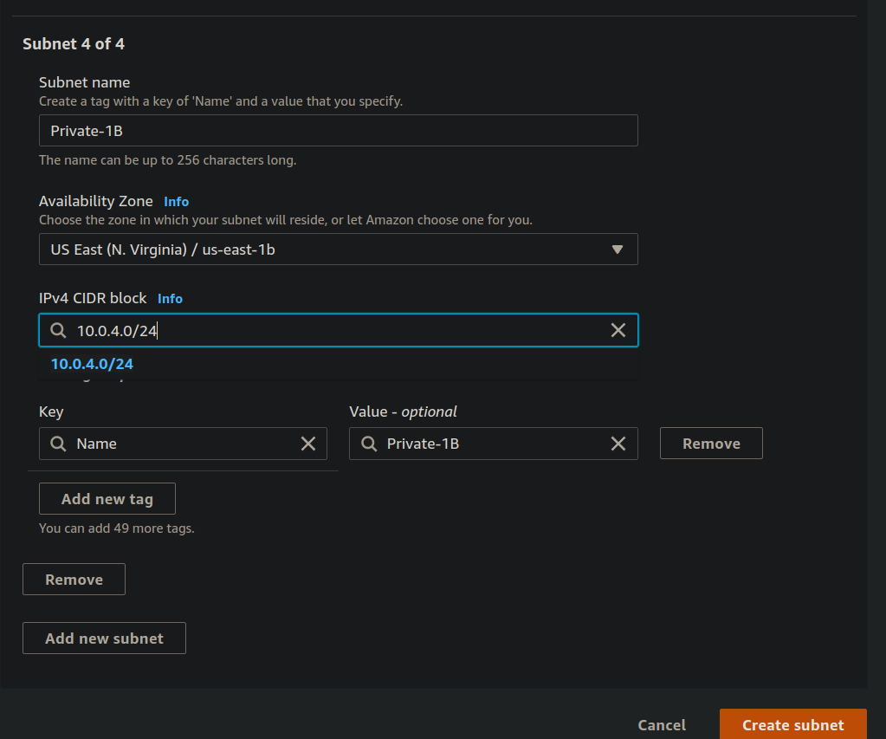

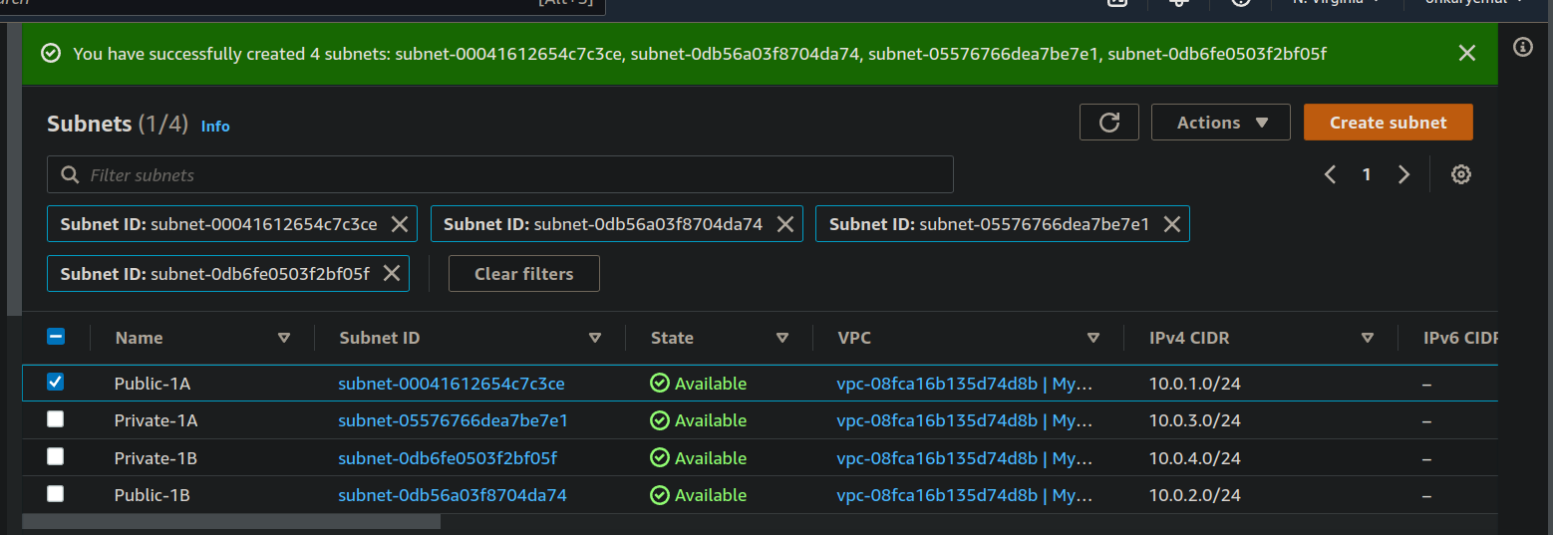

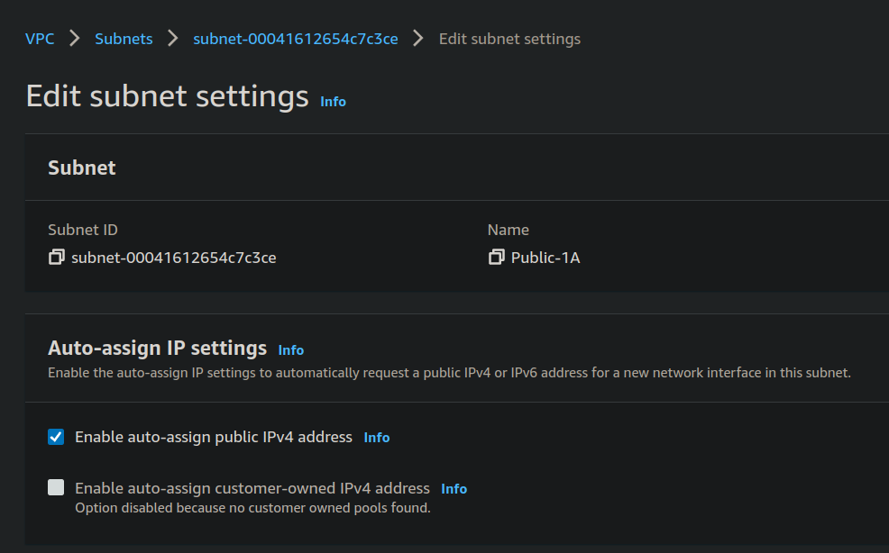

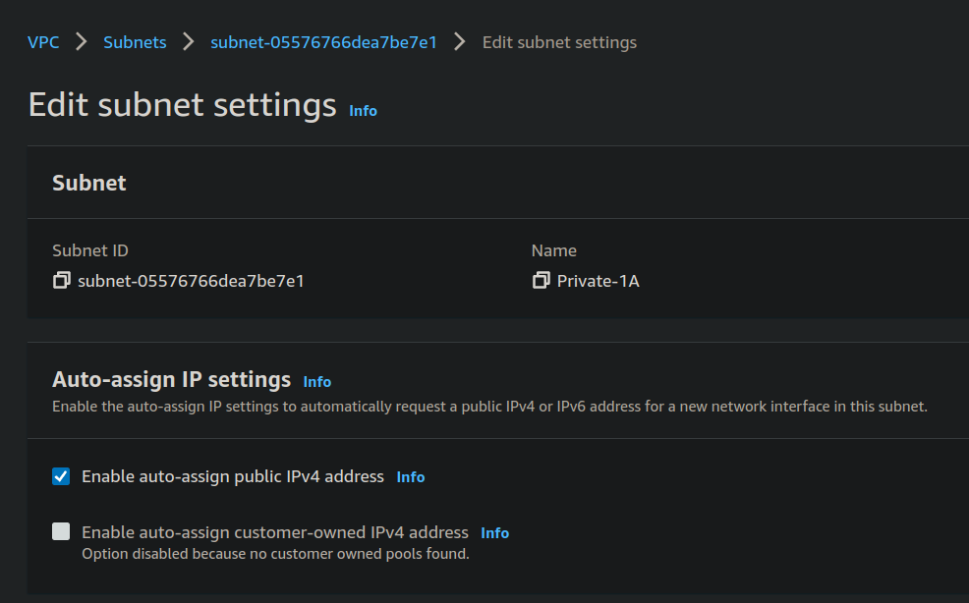

* Now, created Route tables and assigned private subnets to it explicitly by editing subnet associations.

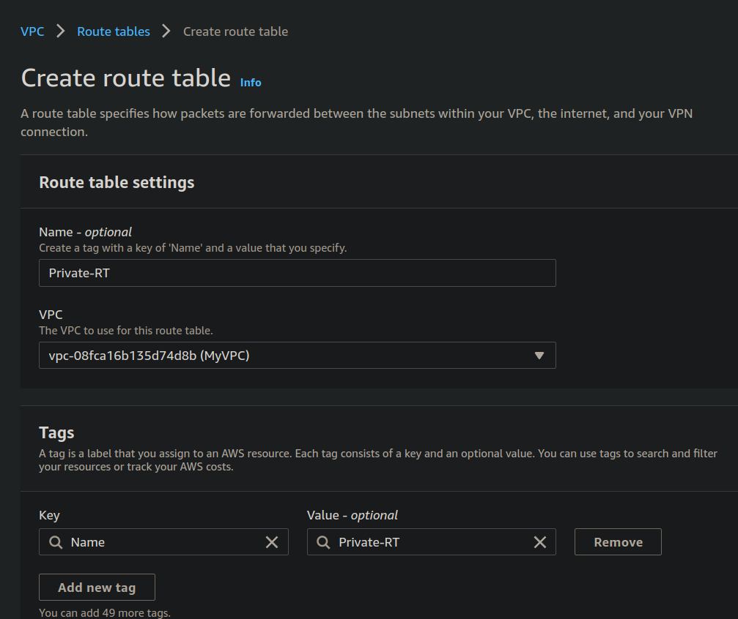

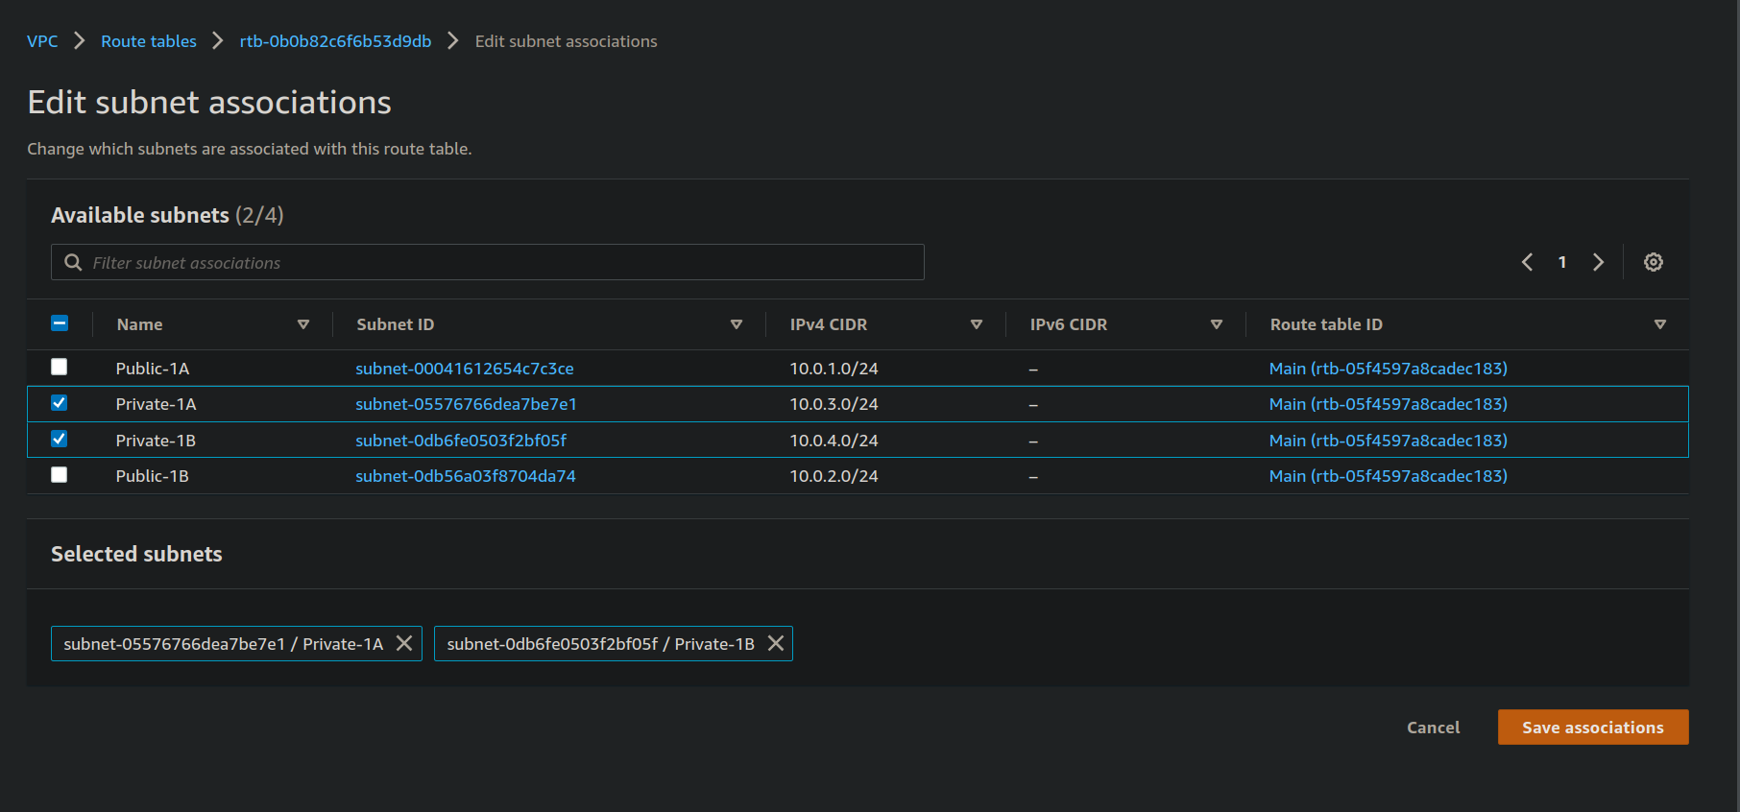

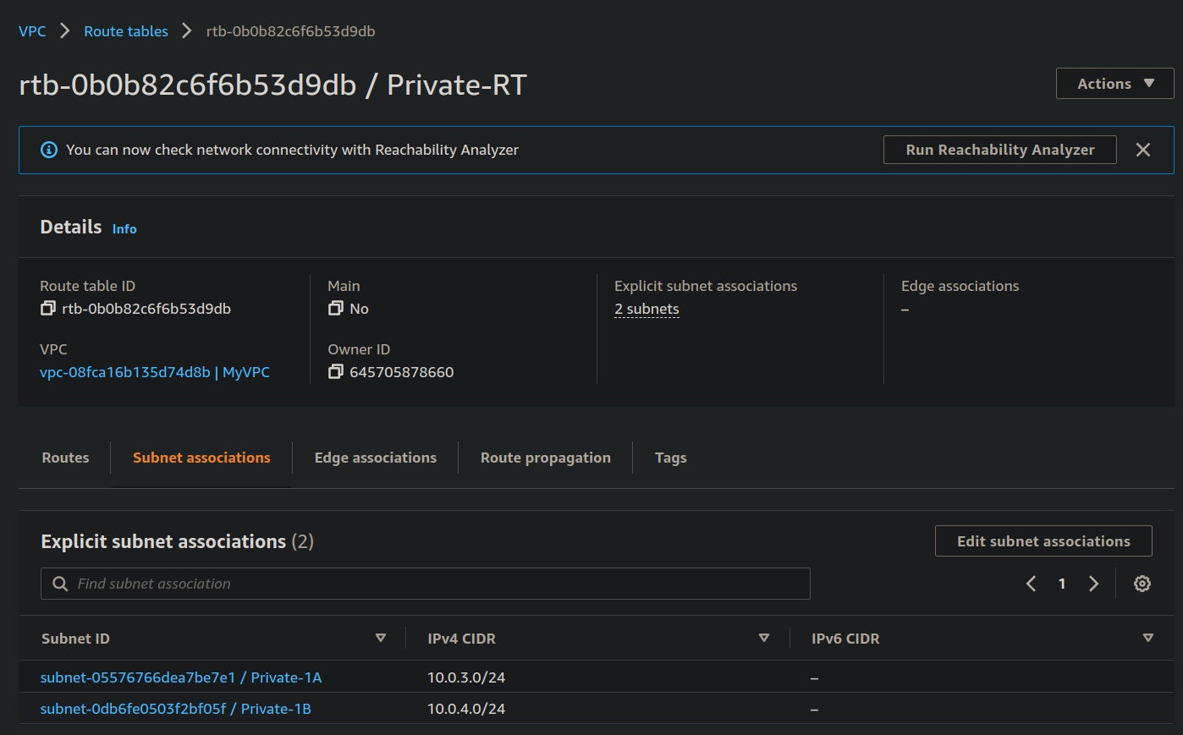

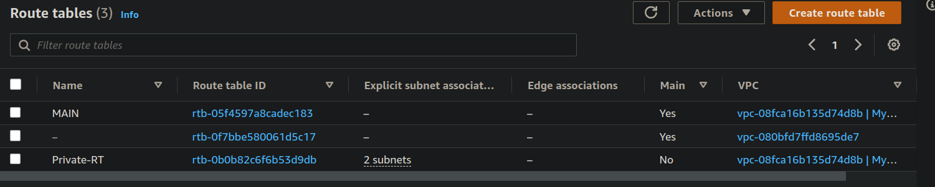

* Now, created internet gateway and attached AWS VPC to it and edited route tables.

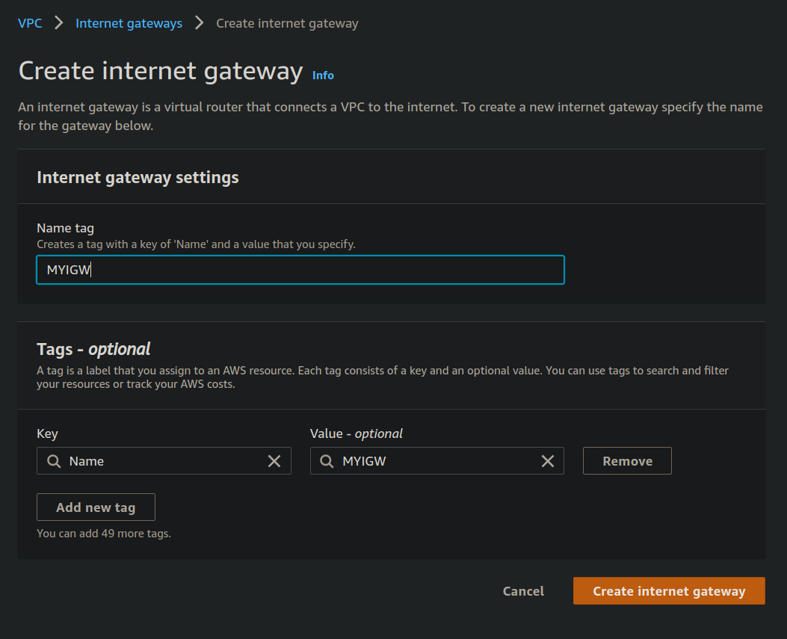

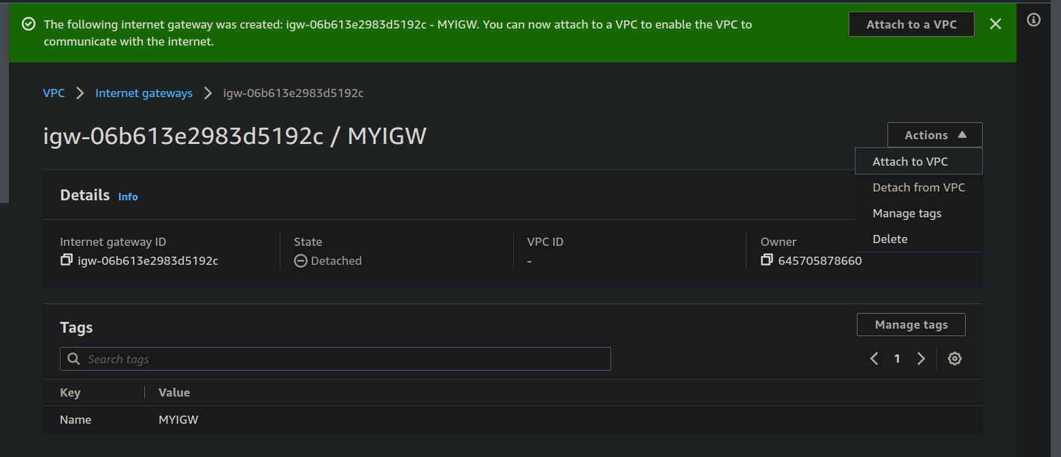

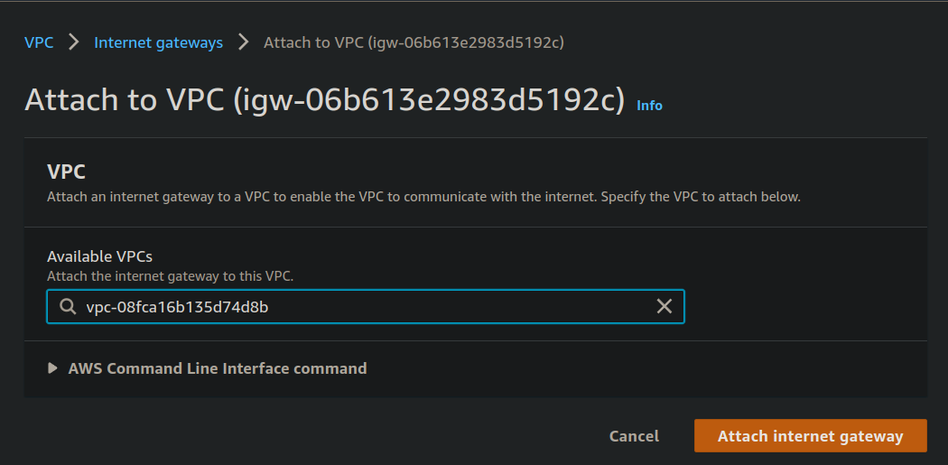

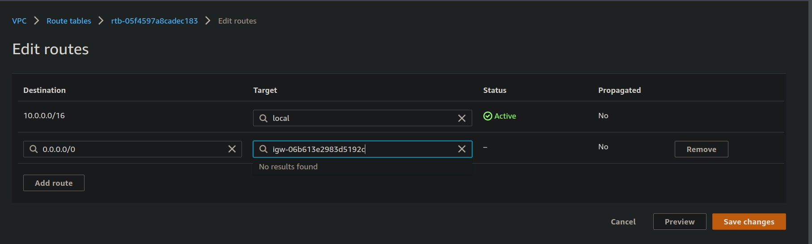

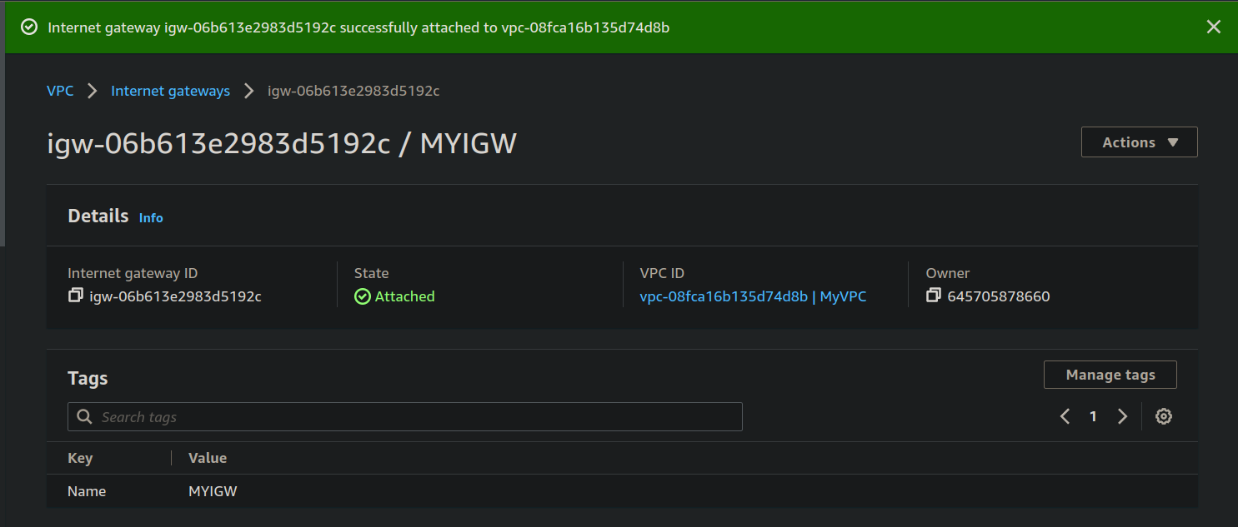

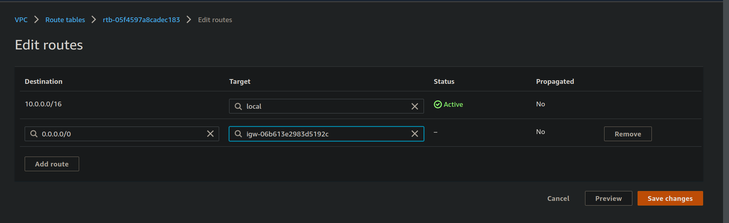

* Created NAT Gateway and edited route tables.

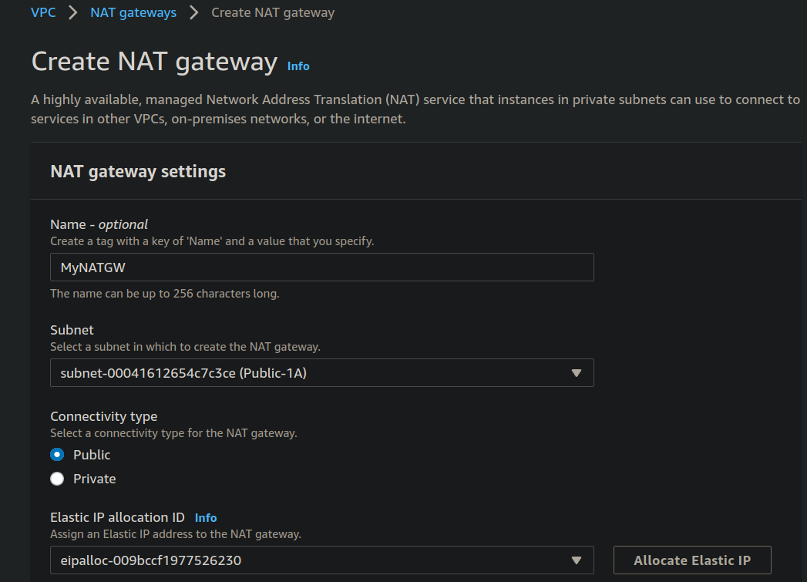

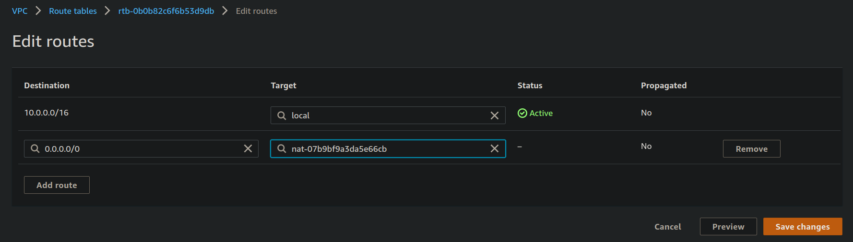

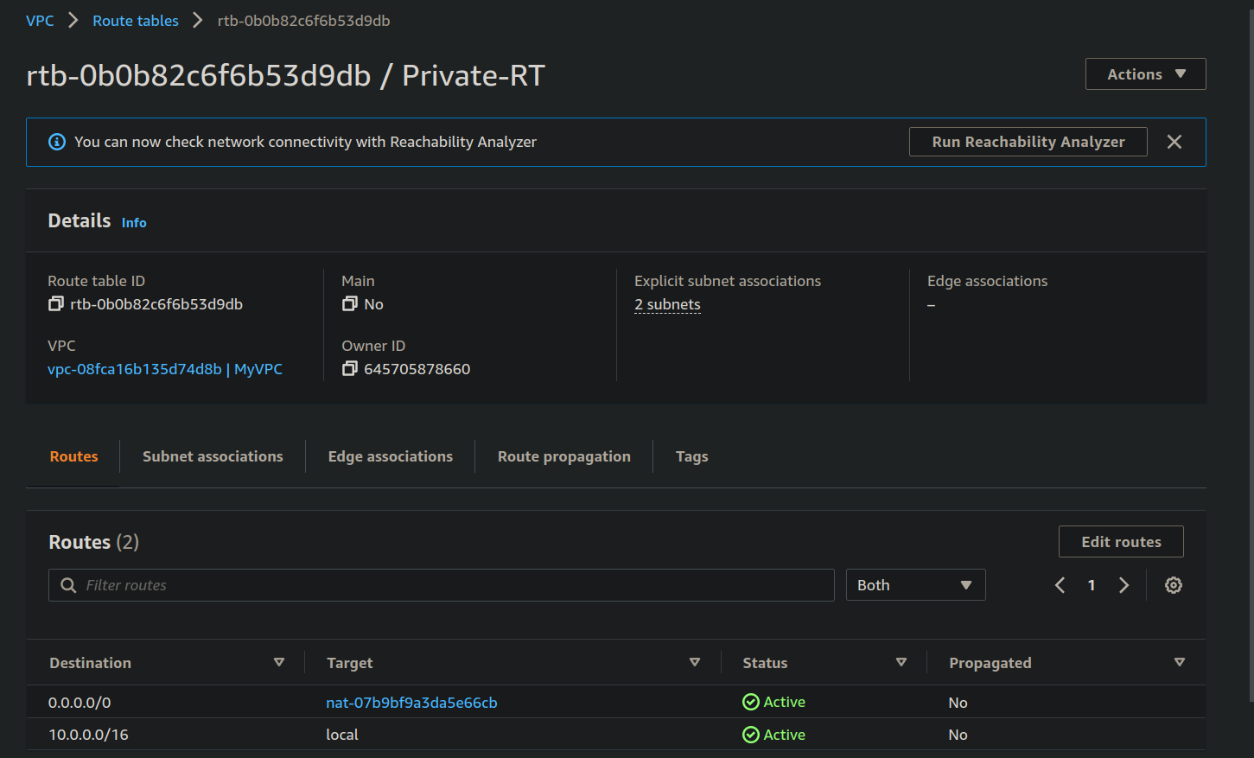

* Created Security groups named “Public Web” and “Private App” and launching AWS EC2 instances through CLI and connecting EC2 instances with other EC2 instances through connect instance and checking for security groups inbound and outbound rules.

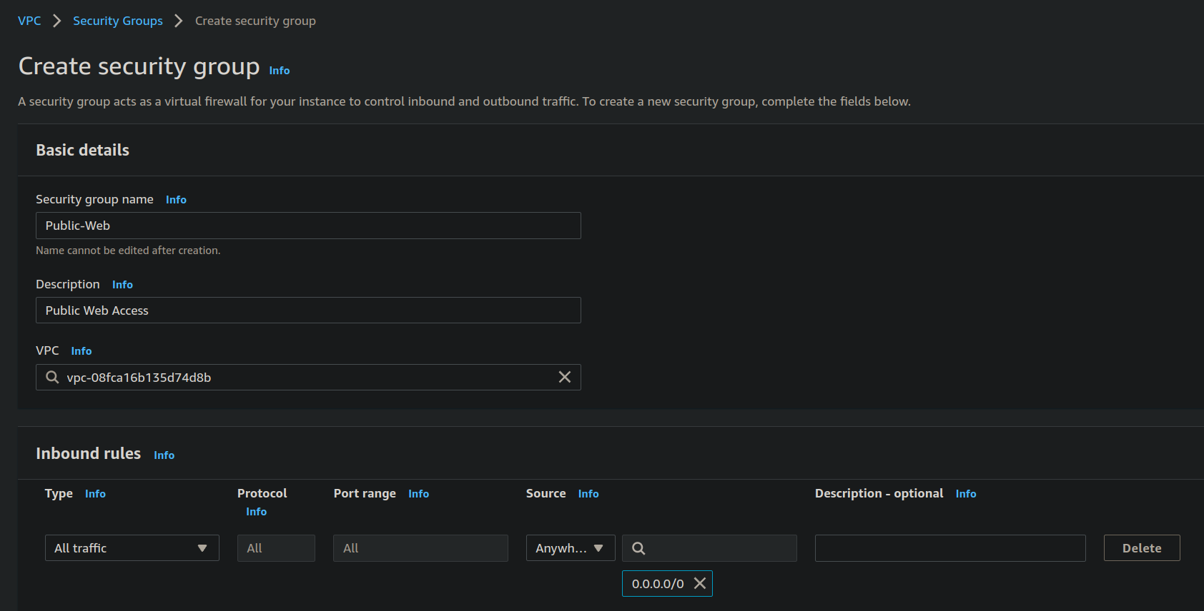

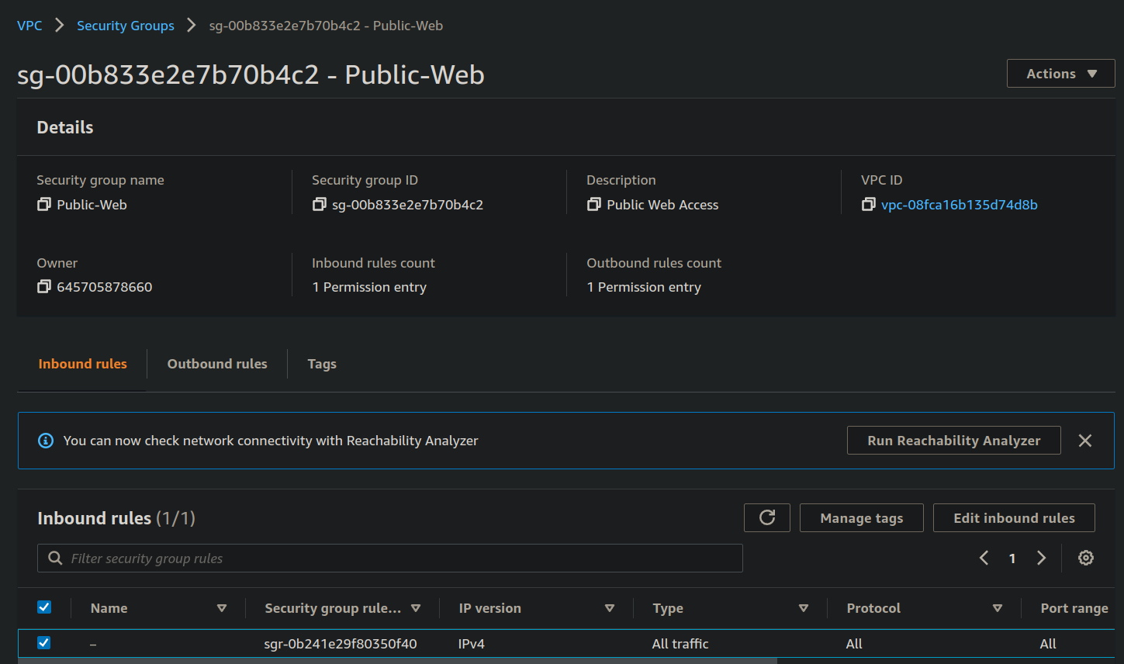

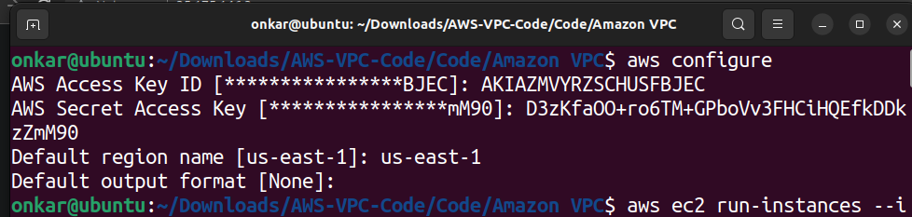

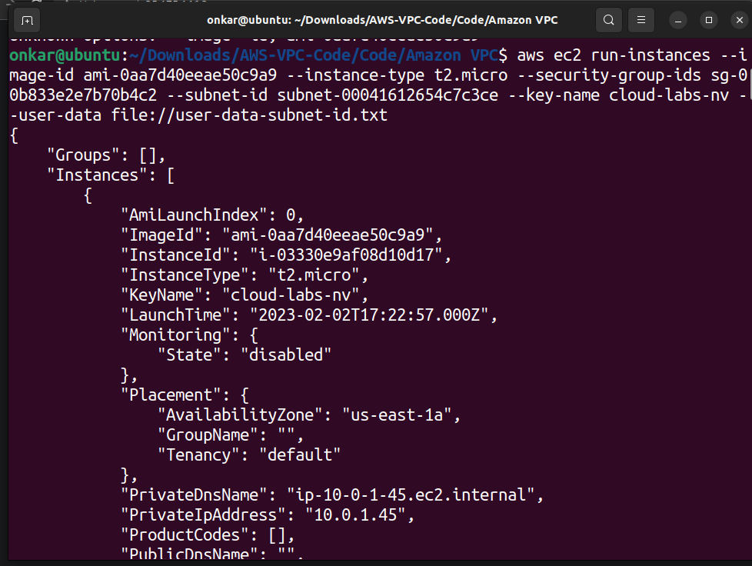

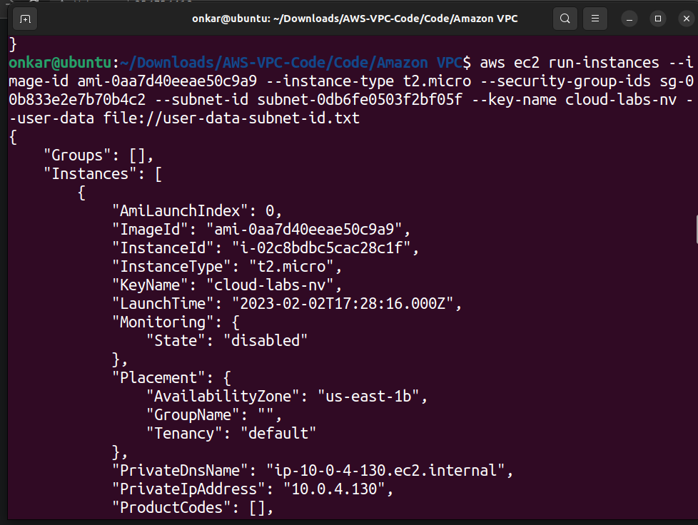

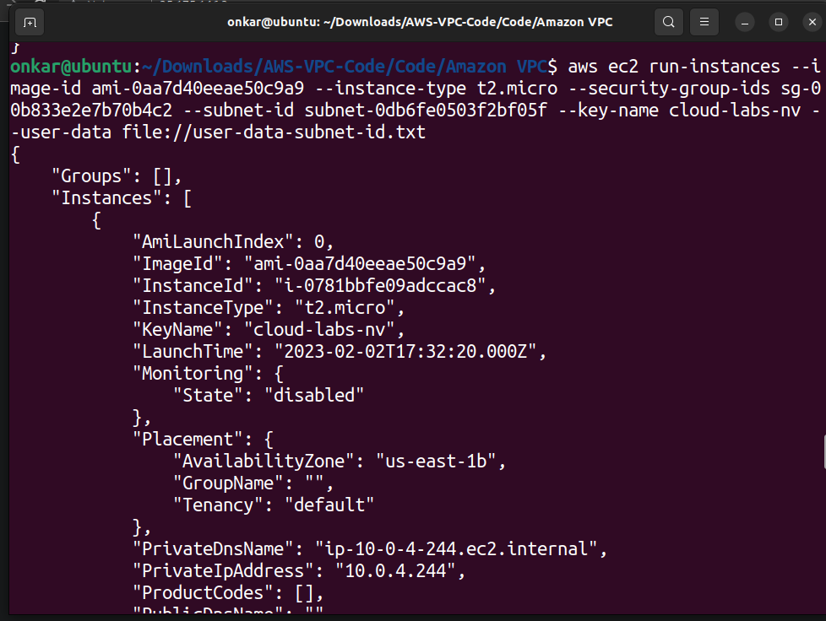

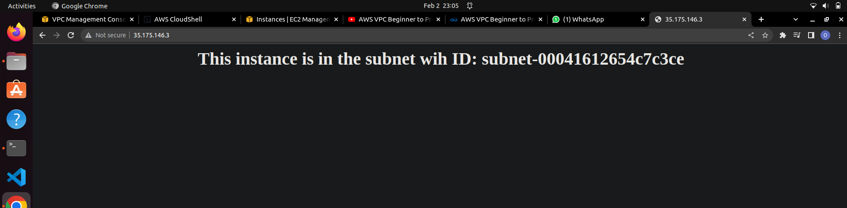

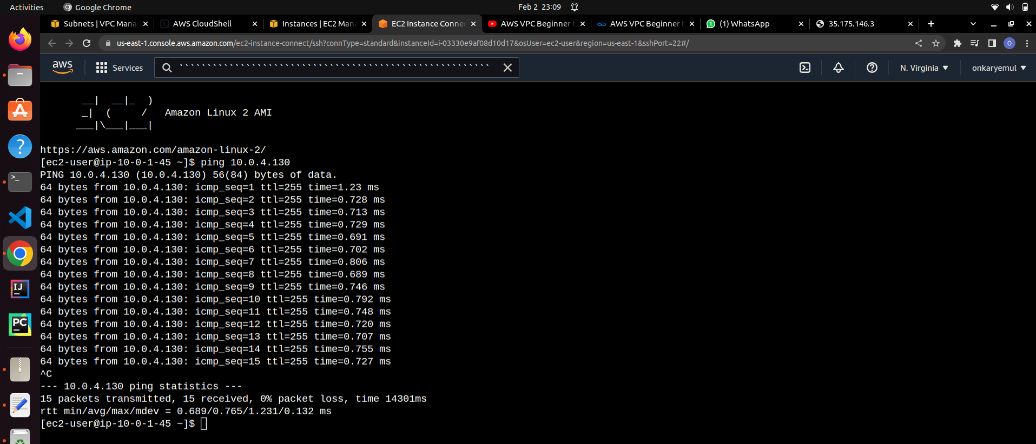

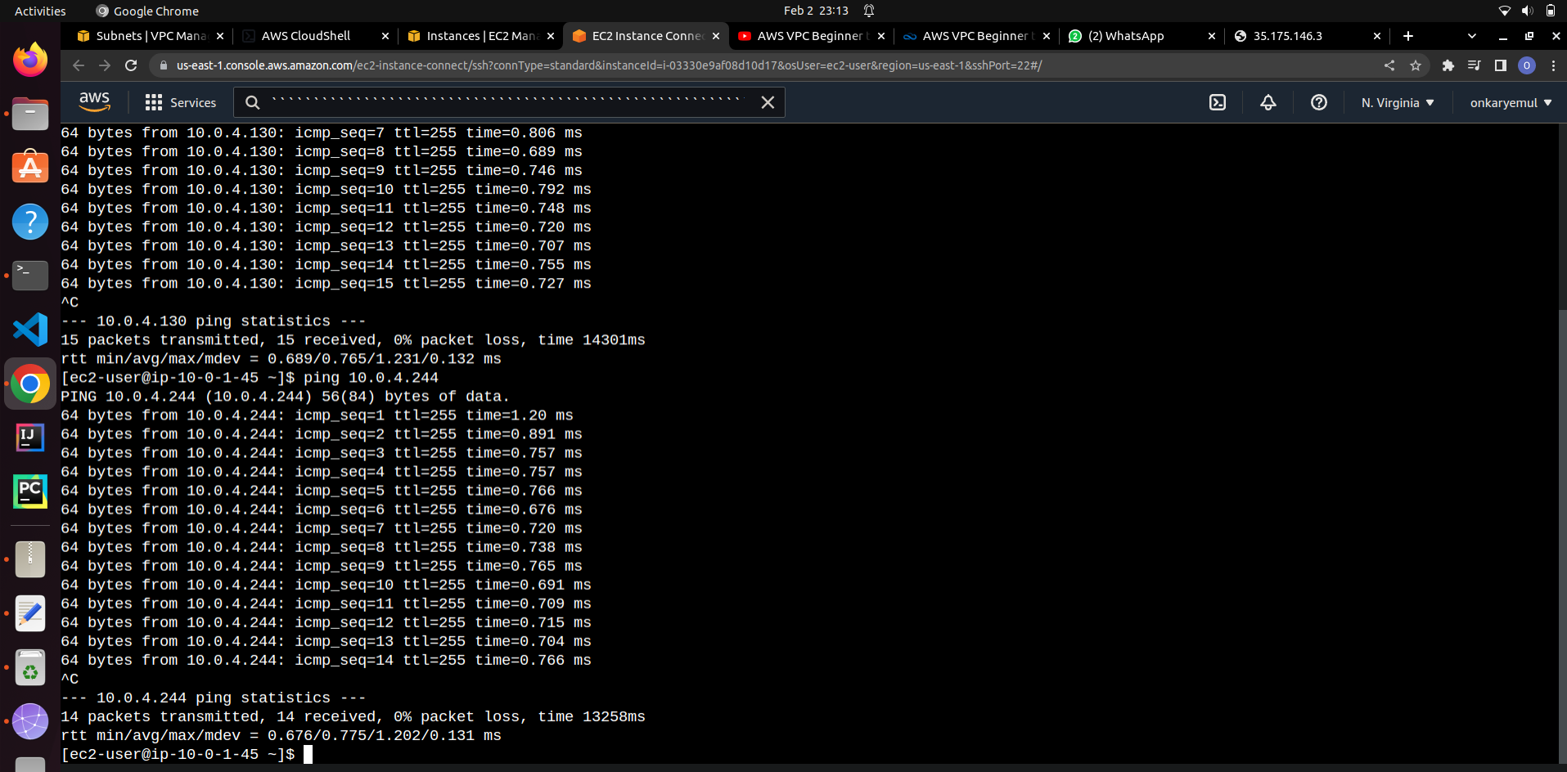

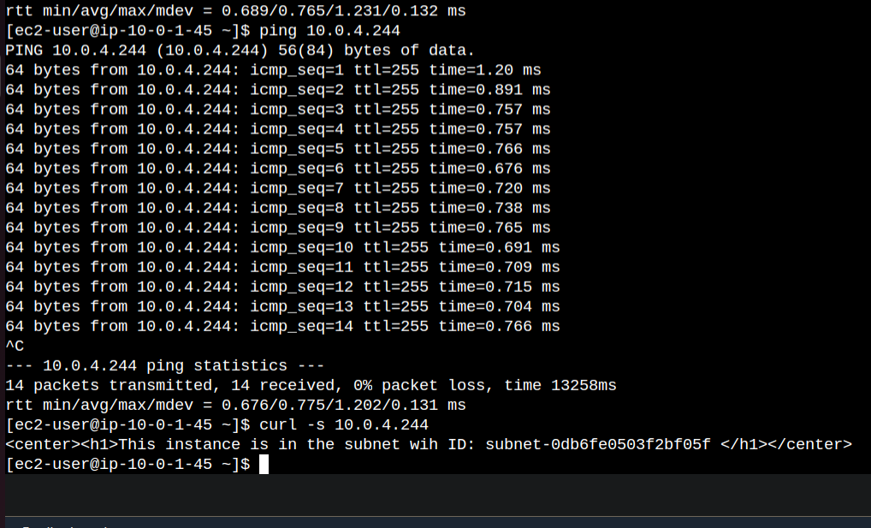

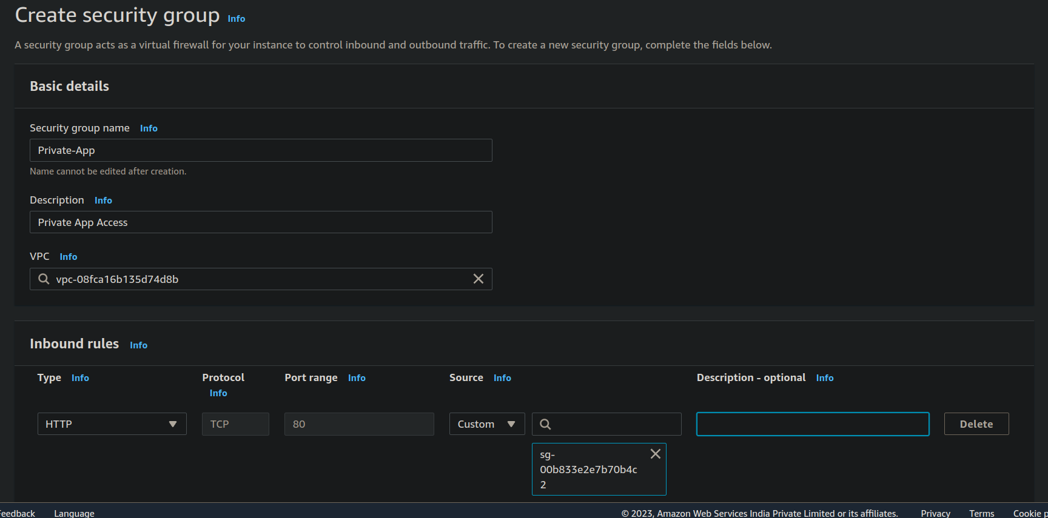

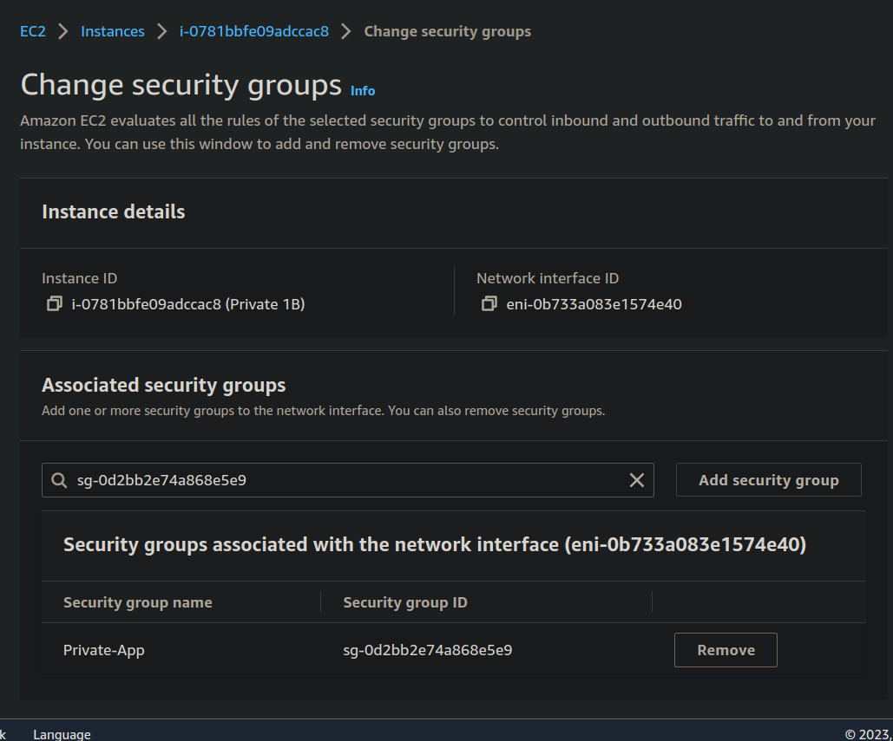

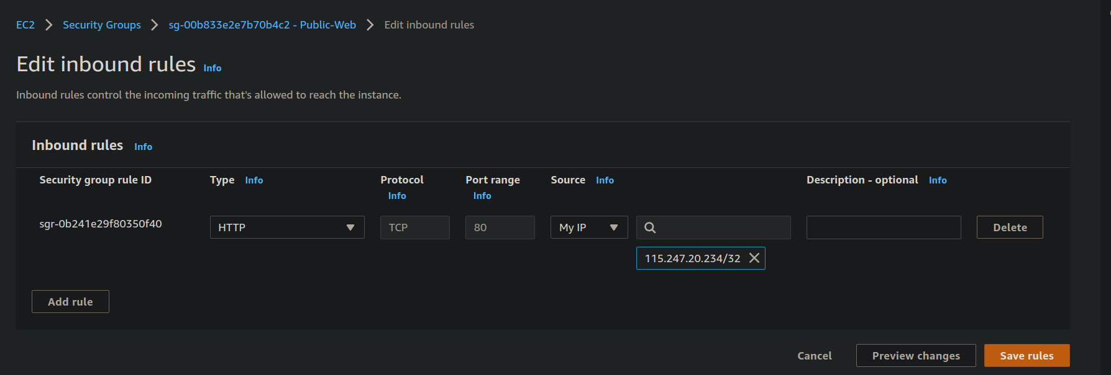

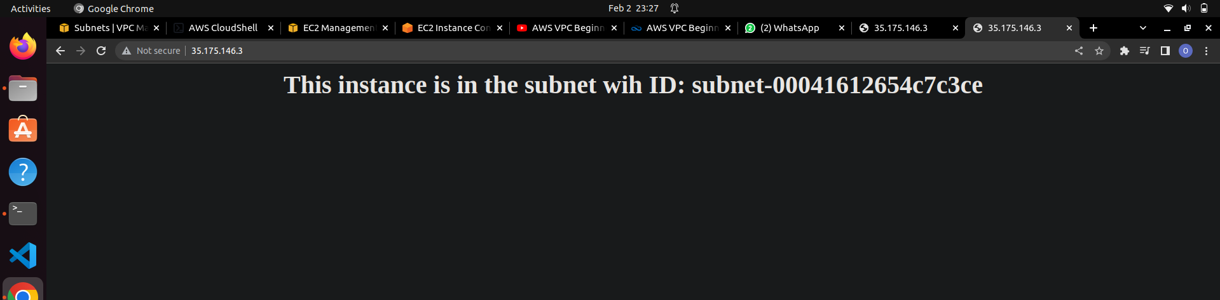

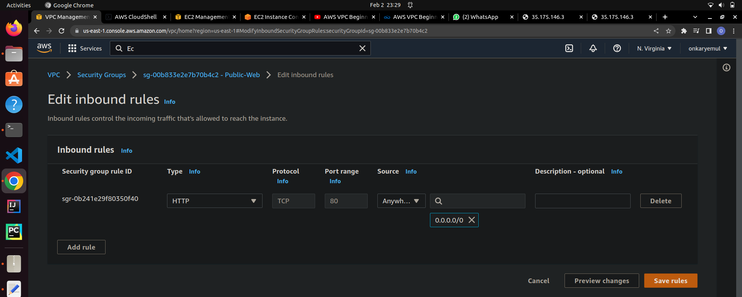

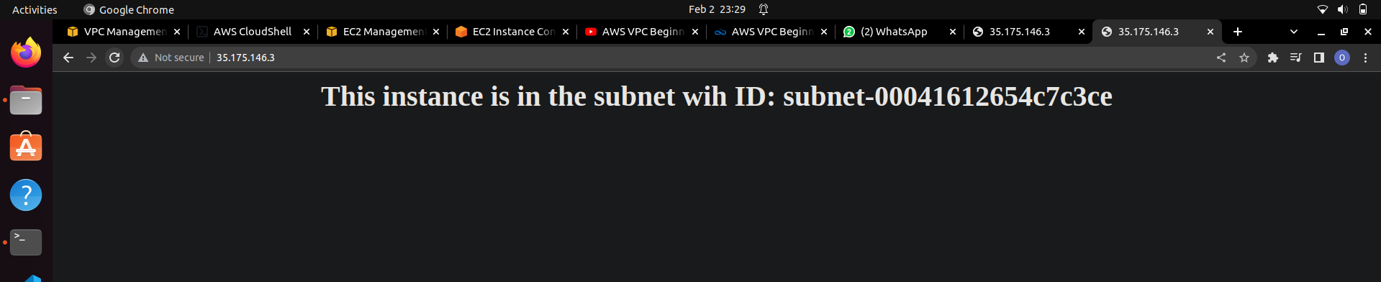

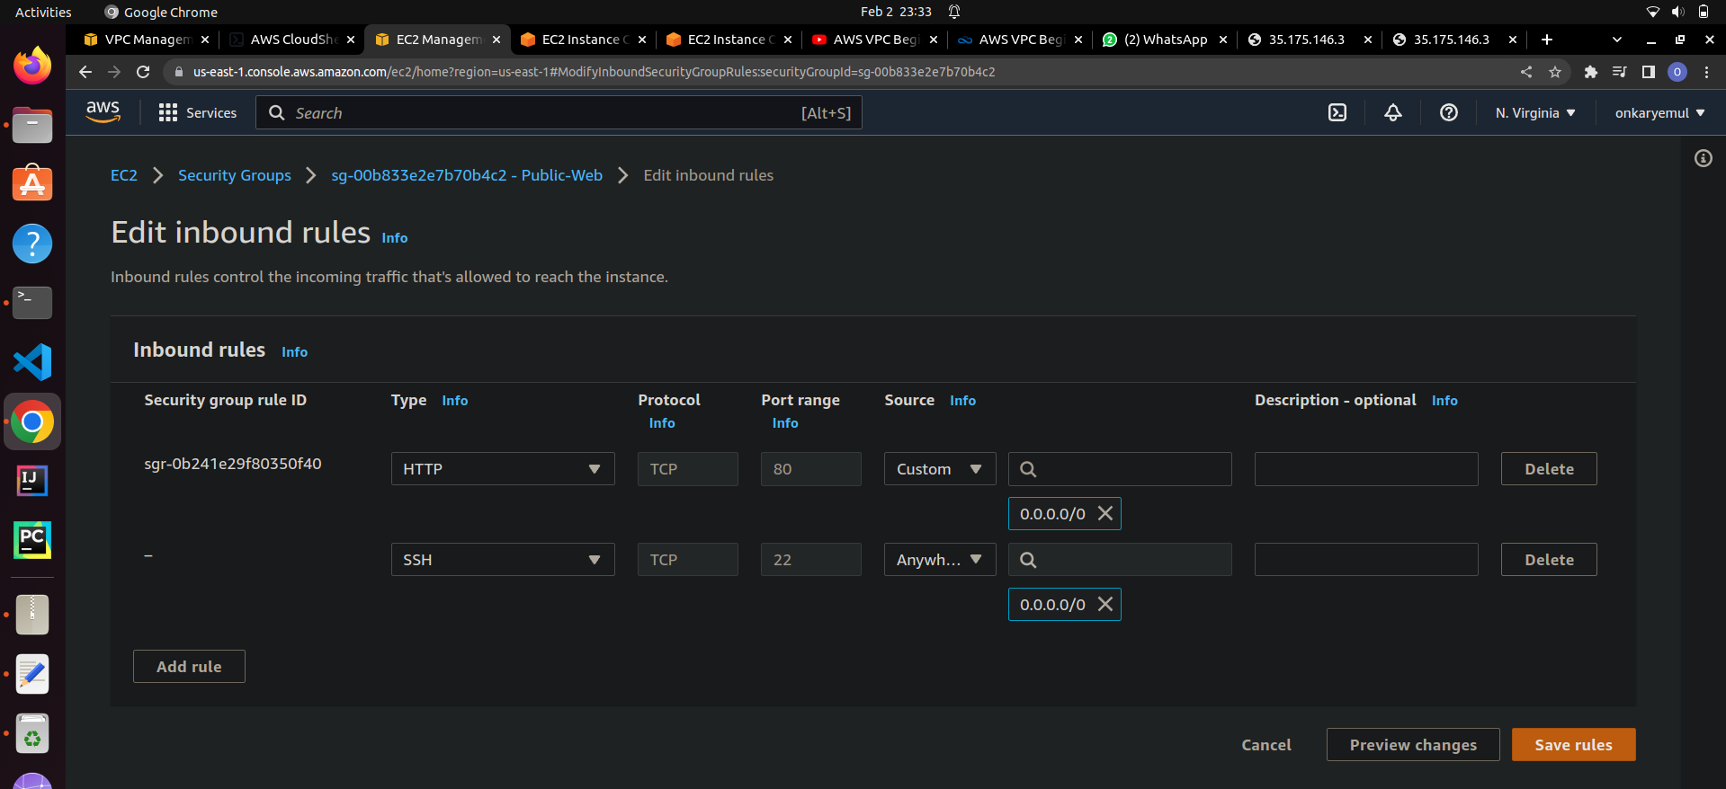

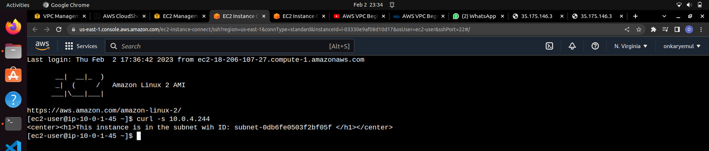

Successfully done!!

Thank you!!